# VIDADALA SRIRAM

## CSA-0783-COMPUTER NETWORKS

1. **Configuration of Network Devices using Packet Tracer (Hub, Switch, Ethernet, Broadcast)**

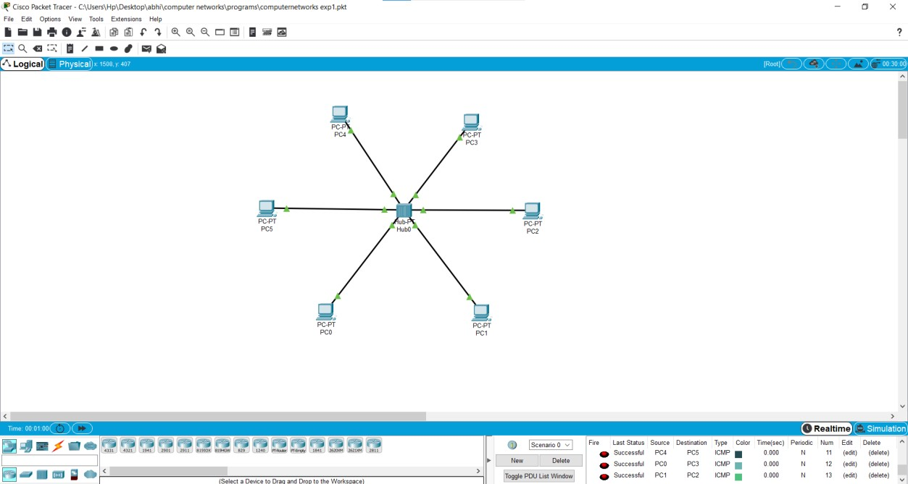

1. **Configuration of Topologies using Packet Tracer (Star, Mesh, Tree,)**

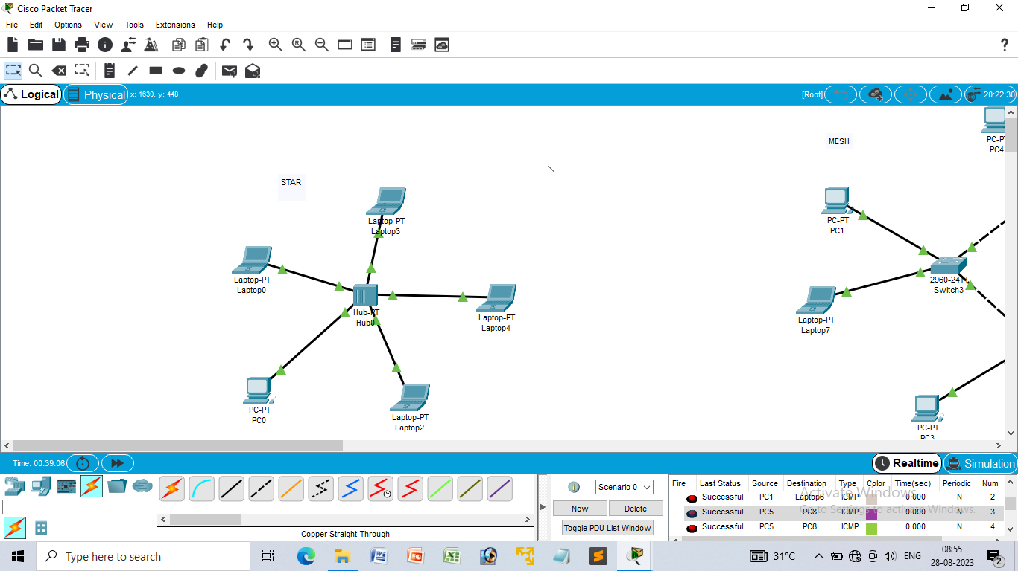

**STAR TOPOLOGY**

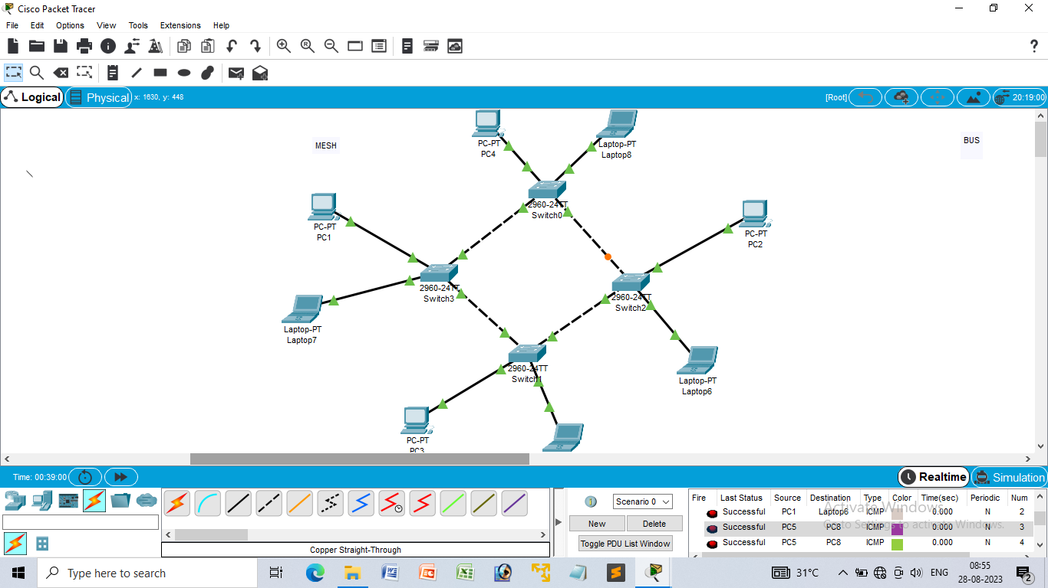

**MESH TOPOLOGY.**

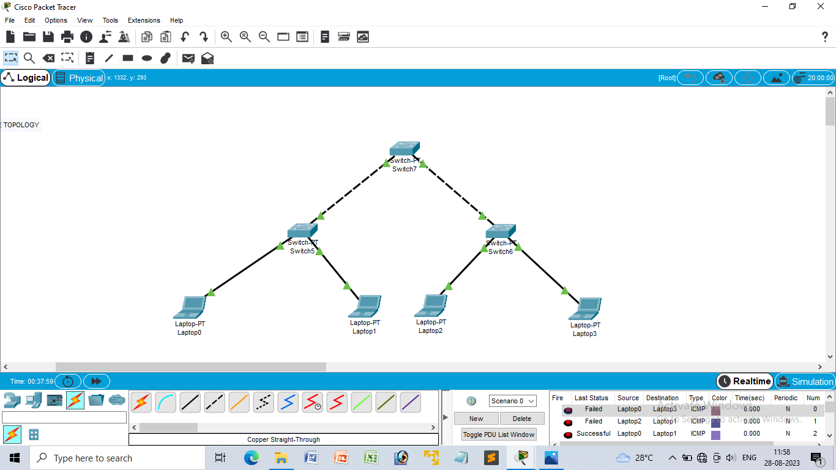

**TREE TOPOLOGY**

1. **Configuration of Topologies using Packet Tracer (Bus, Ring, Hybrid)**

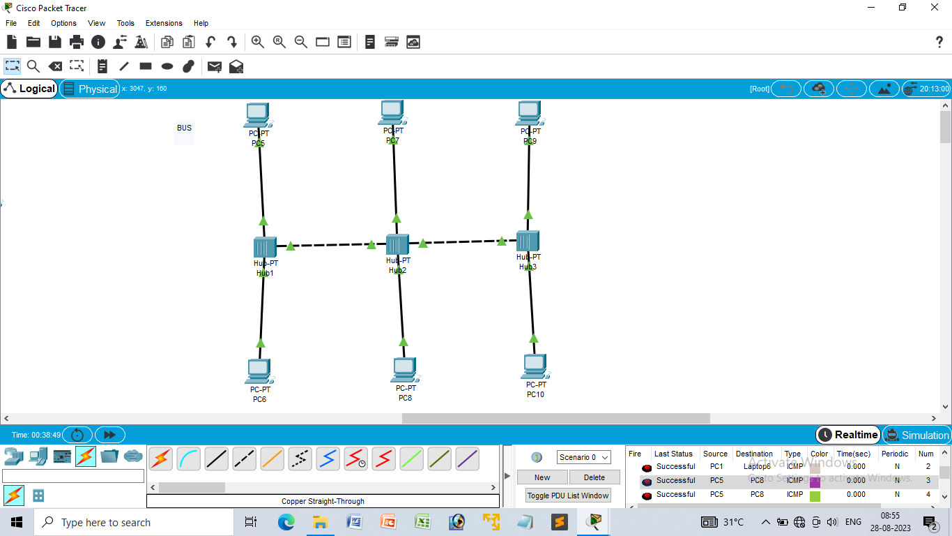

**BUS TOPOLOGY**

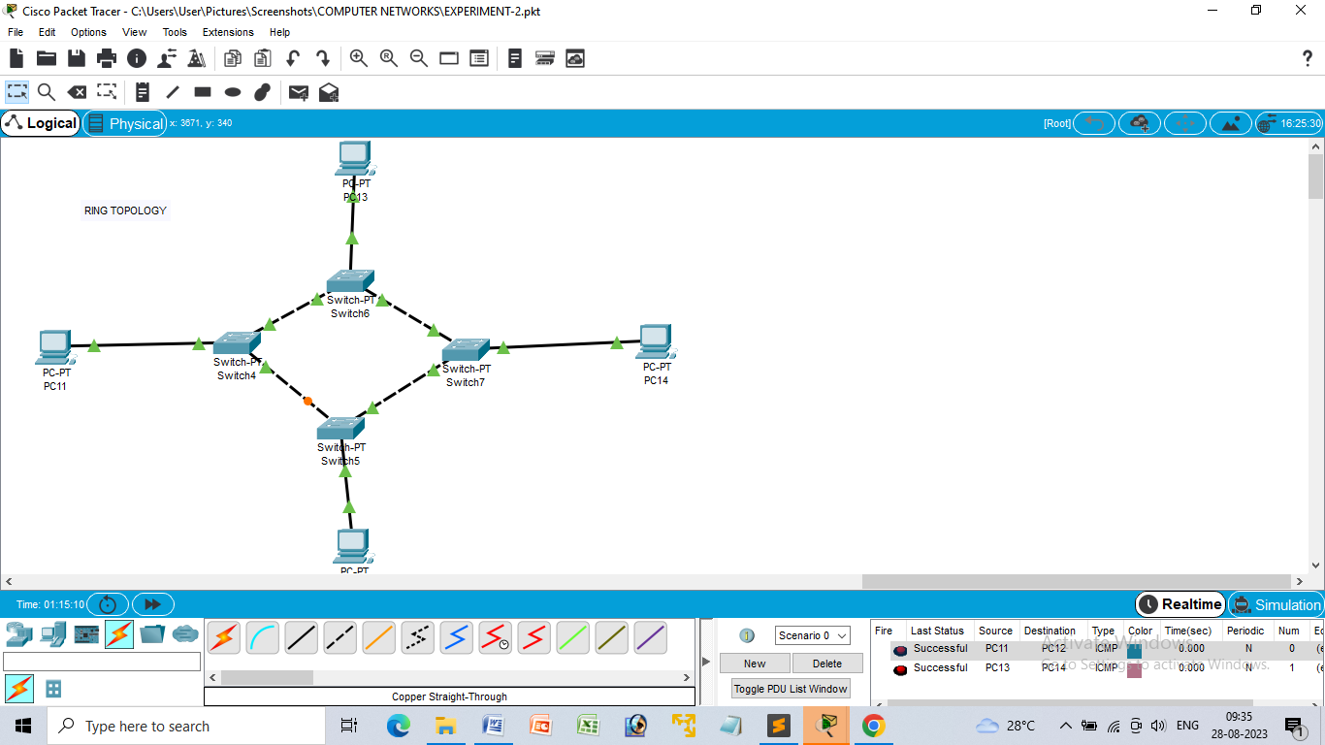

**RING TOPOLOGY**

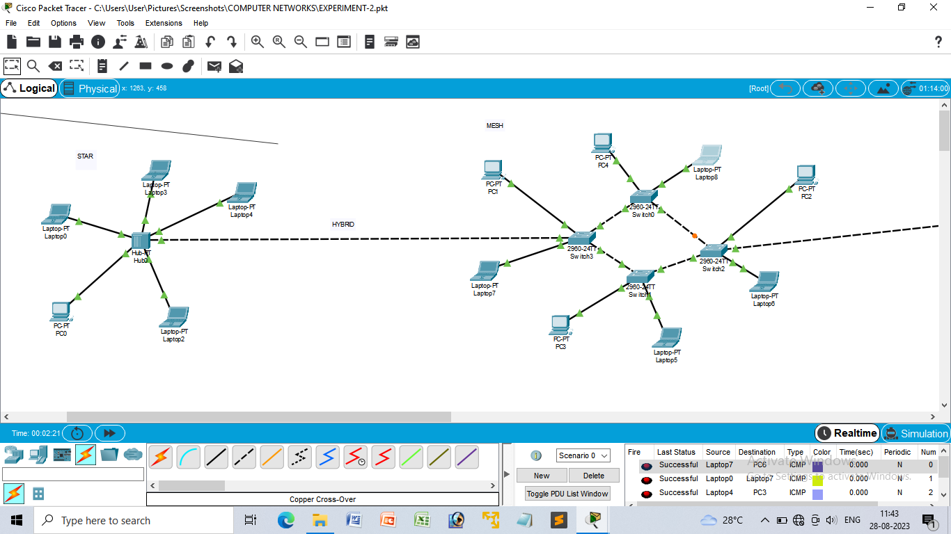

**HYBRID TOPOLOGY**

**4. Data Link Layer Traffic Simulation using Packet Tracer Analysis of CSMA/CD& CSMA/CA**

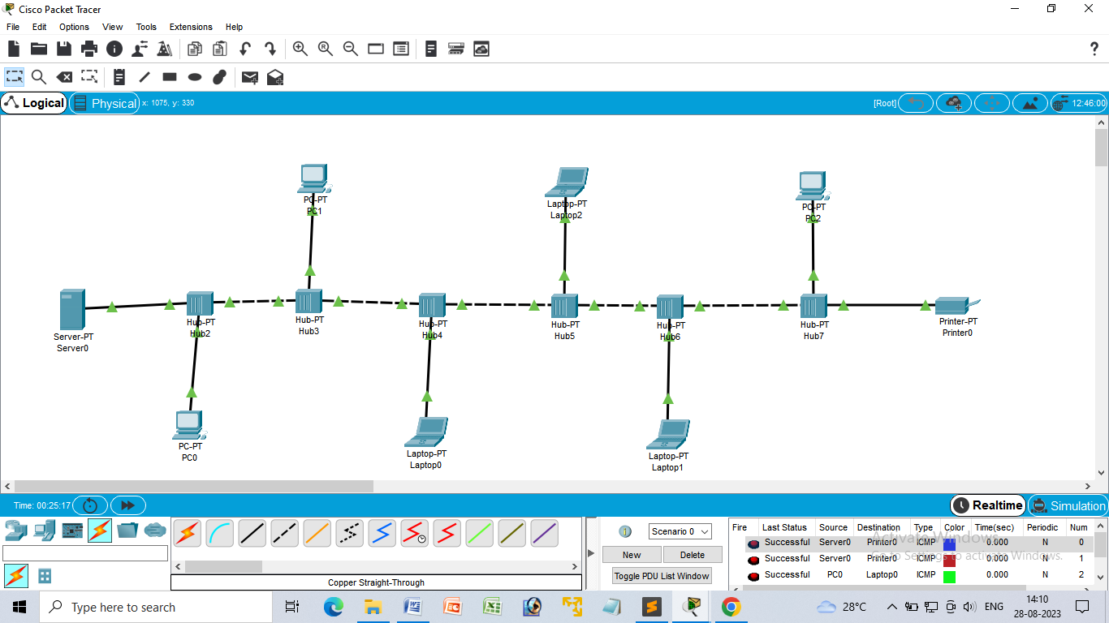

1. **Data Link Layer Traffic Simulation using Packet Tracer Analysis of ARP**

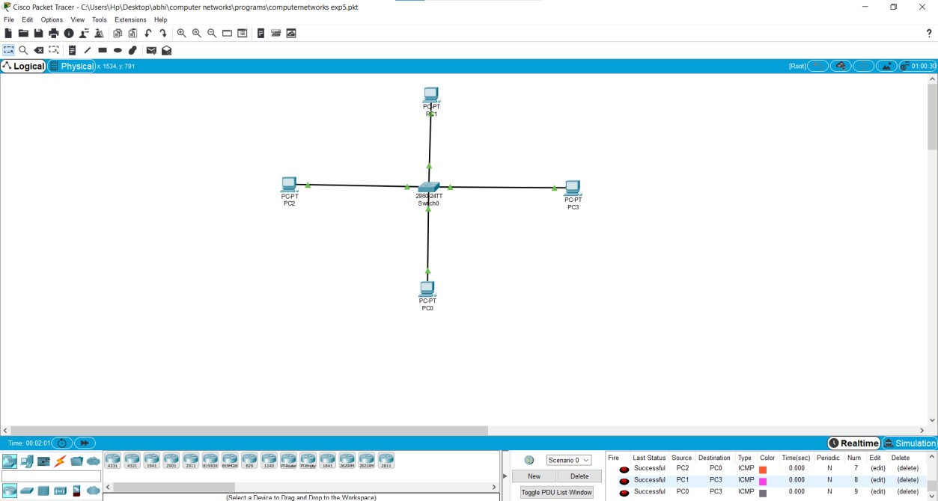

**6. Static Routing using Packet Tracer**

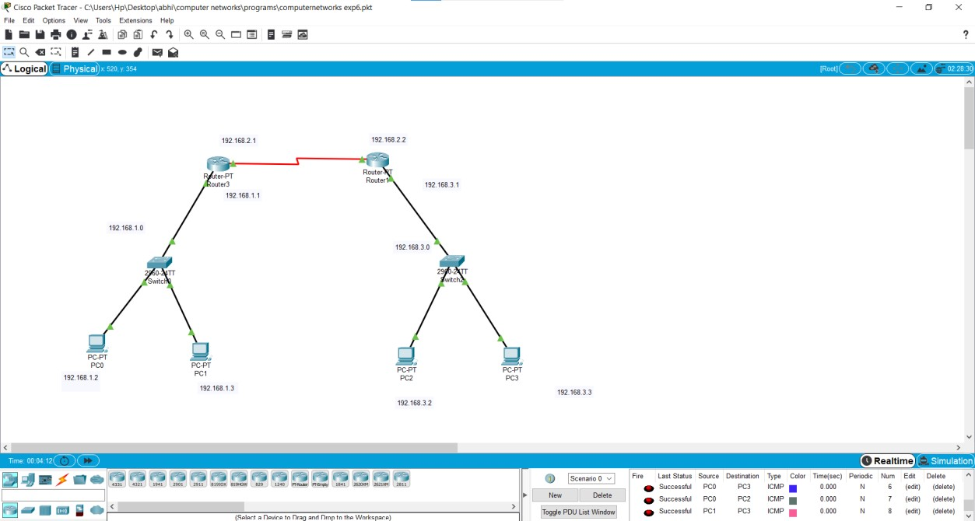

7**. Dynamic Routing using Packet Tracer ( OSPF)**

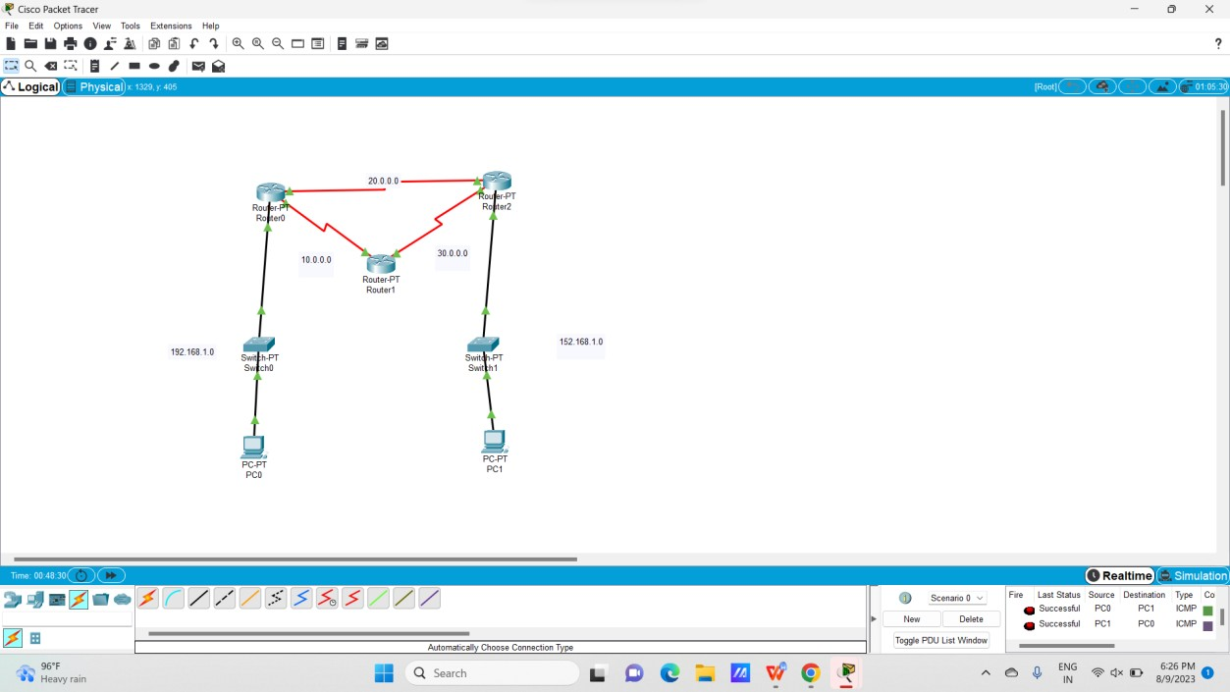

**8. Sub netting – Class C Addressing**

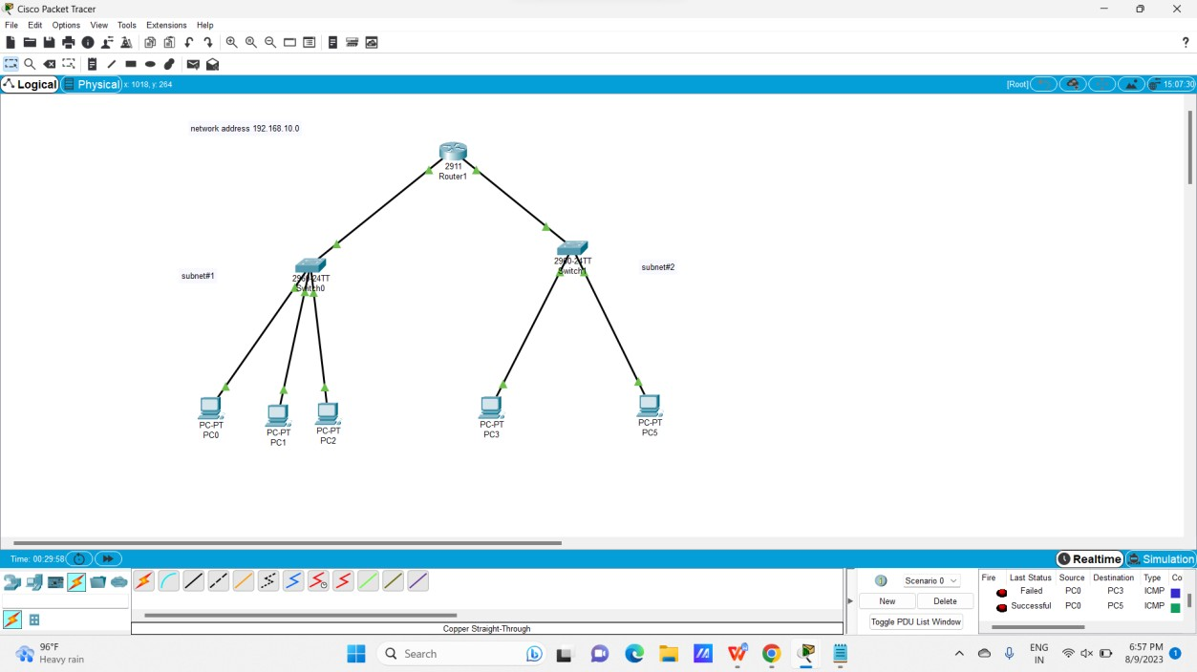

**9. Functionalities of TCP, UD**

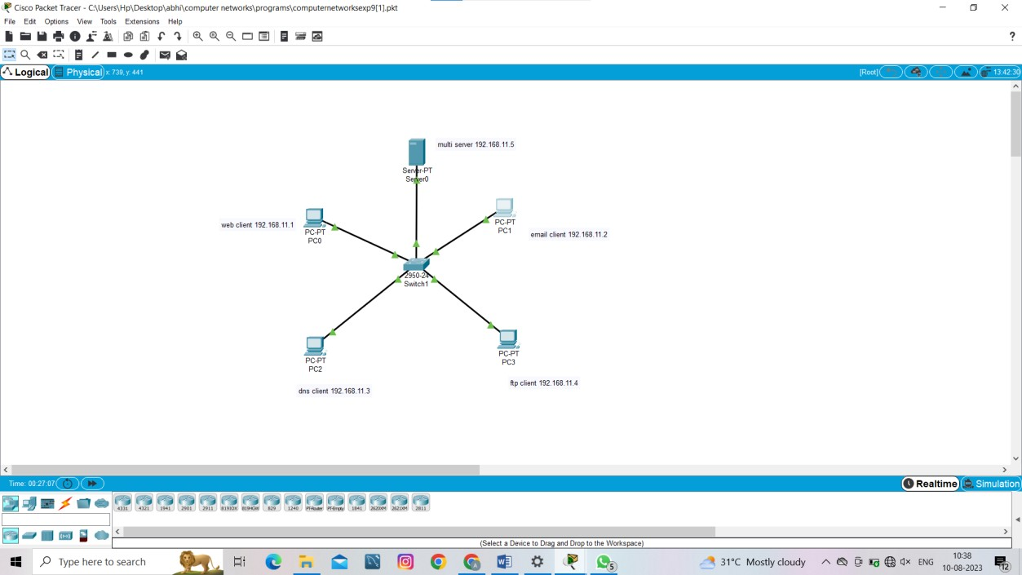

**10. TCP, UDP Exploration Solution**

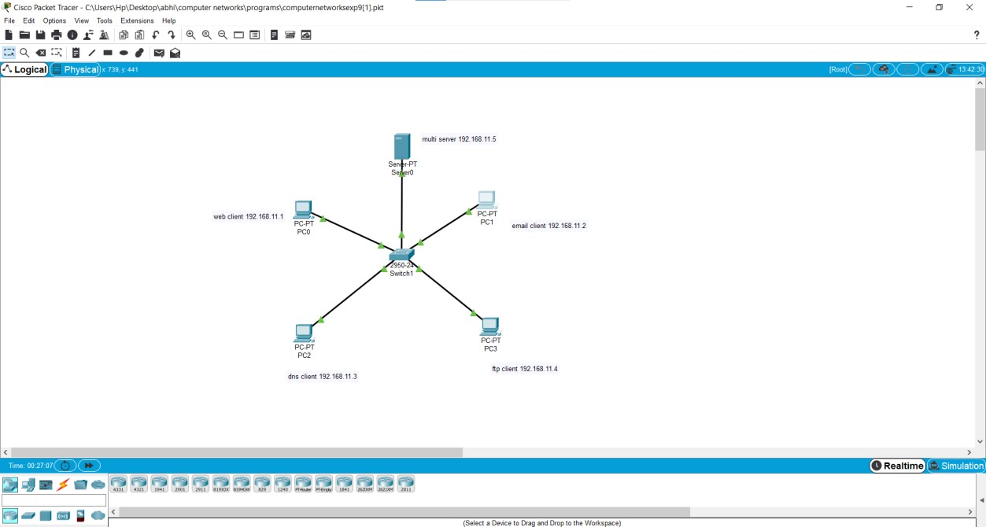

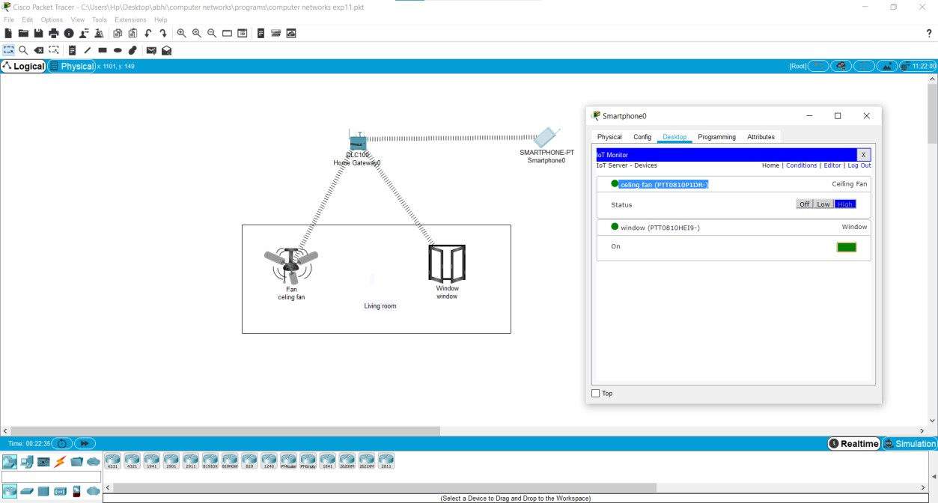

**12.** Smart Garden in Cisco Packet Tracer

